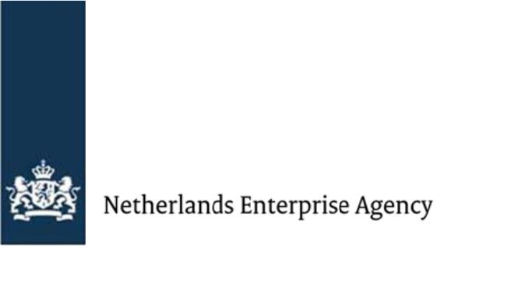

FBK Example template

Management Statement
The board
of
company name
based in
location
makes this management statement to the Netherlands Enterprise Agency (RVO) on the received subsidy under the Fund against Child Labour (FBK):
- During
total project period
- on project
project title
- reference number FVO
reference number

The board
declares that all submitted data and reports are correct and truthful, and follow the grant decision of
day – month - year
Also,
The board
declares that:
- They carried out all activities for which they received a subsidy from the grant decision.
Add a short explanation of the activities
- They fulfilled all obligations as stated in the grant decision;
- The total amount of realised eligible costs is
Insert amount in euros
- The total revenues realised from the FVO project, including third-party contributions, are
Insert amount
(if applicable, not all projects will create revenues); and
- The realised own contribution's total amount is
Insert amount
(the realised own contribution is the difference between the total amount of realised eligible costs and the final subsidy amount received).
- Your final report summarises the B project results and the total costs. We will determine the final subsidy amount based on this report.
- Complete your report and all annexes in English.
- Please send your report with the annexes mentioned below to fbk@rvo.nl:
  - Agreed MoV's per result;
  - Results sheet;
  - Financial budget tool; and
  - Management Statement.
- Send us the final report according to the (amended) grant decision date.
- The lead party must sign the final report.
Read all questions first before you answer them to avoid repetition.
Signatures
President of the board
Name
fill out

Date
fill out.

Location
fill out

Signature
fill out

Project country/countries
fill out

function

Name
fill out.

Date
fill out

Location
fill out

Optional: extra signature(s)

Eligible costs include the overall project costs for Project A and Project B, including the own contribution.
Most projects do not create revenue. An example of income in an FVO project is the project costs for given workshops. In that case, you register the income from those workshops as revenue.

