GUIDE TO
FINANCIAL & PROJECT ADMINISTRATION

(for projects approved from
2009 until the first tender 2011)

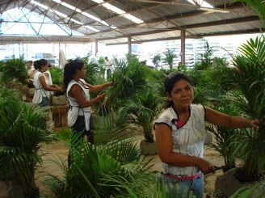

Private Sector Investment Programme
(PSI)
This document is only providing general guidelines on project administration. No rights can be derived from this document. The Netherlands Enterprise Agency / PSI holds the right to diverge from these guidelines whenever necessary. In the case of discrepancies between the PSI Administrative Rules, the PSI Administrative Decision, the PSI Application Form and this document, this document has lower precedence.

TABLE OF CONTENTS
TABLE OF CONTENTS I
LIST OF TERMS AND ABBREVIATIONS III
LEGEND FOR THE WORKFLOWS III
INTRODUCTION 1
1 PROJECT ADMINISTRATION IN A NUTSHELL 3
2 ADVANCE PAYMENTS AND FINAL PAYMENTS 5
3 TECHNICAL ASSISTANCE PAYMENT 7
3.1 Progress Report 8
3.2 Final Report 8
4 HARDWARE PAYMENT 11
4.1 Approval by the Agency / PSI of the goods and services to be purchased 12
4.2 Actual hardware payments 13
5 General notes on payments 17
6 Bank guarantee payment 19
7 Other relevant information 21
APPENDIX i
1.1 Filled out Request to Purchase Goods and Services, including relevant documents i
1.2 Filled out protocol of Receipt vii
1.3 Filled out Protocol of Production ix
1.4 Statement of expenses example x

LIST OF TERMS AND ABBREVIATIONS
Administrative decision / grant award | : | The unilateral contract the Netherlands Enterprise Agency (hereafter: the Agency / PSI) issues for awarding the subsidy. The document specifies the results which should be attained during through the project implementation, as well as the terms and conditions for receiving the grant.
Administrative Rules |  | The publication in the Government Gazette (Staatscourant).
Applicant | : | Company or 'corporate foundation' submitting the application for a PSI subsidy. This organisation is at all times the primary point of contact and the responsible party for the Agency / PSI concerning the project and the project proposal.
Bill of lading | : | An official document issued by the carrier, proving that the goods have been cleared and will be delivered to the addressee.
HW | : | Hardware. The portion of the project budget allocated for investment in tangible goods, such as machines, buildings and installations (computer software is also included in this category). Goods used for a single production cycle only, are not seen as investments in hardware but rather as operating costs.
Local Partner | : | Company in the PSI country who will implement the project with the Applicant and any Third Partner(s).
MoV | : | Means of Verification. Agreed indicators that serve as proof that a Project Result has been realised.
Project Results | : | The measurable and verifiable results of the project as stipulated in the grant award.
PSI grant | : | The part of the total project budget that PSI will finance.
RPGS | : | Request for Purchase of Goods and Services; a Model Form in which the Applicant requests the Agency / PSI for permission to purchase goods and directly related services.
Spin-off phase | : | A period of two years following the project in which the Applicant makes an effort to realise the project's expected spin-off results.
TA | : | Technical Assistance. TA encompasses all costs for project management, training, certification, legal and construction advice, etc. This is the part of the project budget not spent on hardware.
Verification | : | Inspection carried out by the Agency / PSI or an organisation / independent person assigned by the Agency / PSI, in order to establish whether the Applicant has indeed achieved the results agreed upon.

LEGEND FOR THE WORKFLOWS
Decision Box
Action box

Document

INTRODUCTION
This document is meant to provide the main guidelines regarding the project administration of PSI projects. Since PSI projects are result based, the financial administration (payments) and the rest of the project administration (progress reporting) are interrelated. The PSI grant is paid in tranches, according to the advance payment schedule attached to the grant award received from the Agency / PSI. The purpose of this guide is therefore to clarify what you need to submit and at which stage, in order to get the PSI grant in a timely and most efficient manner. The instructions provided in this document are leading for the PSI processes. However, the Agency / PSI does keep an ear open for individual circumstances. You should always consult with your Project Officer when you want to diverge from the standard processes as described in this document. Experience indicates that the most important factor for a successful collaboration is communication.

The administration will mostly consist of submitting standard forms and their attachments. All the forms needed for the administration (and described in this document) are available on the PSI website: www.rvo.nl/en/psi (under Financial and project administration).

The first chapter of these guidelines summarises all the information regarding project administration. Chapter 2 of this guidelines explains the difference between advance payments and final payments. Chapter 3 deals with payments related to technical assistance, while HW payments are elaborated in chapter 4. Payments on the basis of bank guarantees are explained in chapter 5, while chapter 6 discusses other relevant information. Further one can find the correctly filled out standard forms in the appendix.

PLEASE PAY ATTENTION

This guide applies to PSI projects approved from 2009 to the first tender 2011.

PROJECT ADMINISTRATION IN A NUTSHELL
From Advance to Final Payments:
- Initially, all payments are advance payments; the Applicant cannot derive any rights from an advance payment.
- Advance payments are turned into final payments upon the completion of the project and only after verification by the Agency / PSI. The project is than settled (fixed).

TA (technical assistance) Payment:
- Takes place upon completion of a result as defined in the grant award.
- For TA payment one needs to hand in the model form for Progress Report or Final Report (only for the last result) and attach the MoVs required for the completion of the result.
- For hardware related results, please make sure all hardware documents (at least the invoice and the Protocol of Receipt) have been delivered.

HW (hardware) Payment:
- One needs to first get approval for purchase of goods from the Agency / PSI – by handing in a completed Request to Purchase Goods and Services (RPGS) together with the offers / quotations / pro-forma invoices for every HW items requested. A maximum of three (3) RPGS can be submitted for hardware approval during the project implementation. You can also purchase hardware before obtaining approval from the Agency / PSI. In that case you take the risk that the hardware might not be approved or might be approved for a lower amount upon evaluation.
- Takes place in tranches:
- 1st tranche – 80% based on submission of order confirmation OR invoice AND market conformity certificate (obtained by the Agency / PSI).
- The Protocol of Receipt and the invoice (if not submitted for the 1st tranche) need to be submitted for the completion of the corresponding result and the payment of the respective TA.
- 2nd tranche – 20% based on submission of the Protocol of Production. This tranche will be paid with the settlement of the project, at the end.
Payment schedule

TECHNICAL ASSISTANCE

 | 1st Month | 2nd Month | 3rd Month | 4th Month | 5th Month | 6th Month | 7th Month | 8th Month | 9th Month | 10th Month | 11th Month | 12th Month | 13th Month | 14th Month | 15th Month | 16th Month | 17th Month | 18th Month | 19th Month | 20th Month | 21st Month | 22nd Month | 23rd Month | 24th Month
Result 1
Result 2
Result 3 |  |  |  |  |  |  |  |  |  |  |  |  |  |  |  |  |  |  |  |  |  |  |  | FINAL  PAYMENT  (SETTLEMENT)
Result 4

80% 20%
HARDWARE
Bank Guarantee Advance Payment
- Is valid only when the bank guarantee is specified in the grant award.
- Can cover maximum 30% of the total PSI grant as stipulated in the grant award.
- Is paid upon completion of Result 1.

Statement of Expenses
- Overview of the project administration.
- Comes with every relevant letter and is adjusted according to the last changes.

Spin-off Report
- To be submitted within four (4) weeks after the end of the spin-off phase.
- One should use the model form provided by the Agency / PSI.

ADVANCE PAYMENTS AND FINAL PAYMENTS
All payments issued by the Agency / PSI are initially advance payments. As such the Applicant can not derive any rights from these payments until they are made official.

During verification, the Agency / PSI checks whether the delivered MoVs (Means of Verification) are in accordance with the results specified in the administrative decision and/or HW is purchased in accordance with the specifications included in the RPGS (Request for Purchase of Goods and Services).

The advance payments are turned into final payments upon completion of the project (after approval of the Final Report), once all results will have been verified by the Agency / PSI.

PLEASE PAY ATTENTION
- All HW items can only be verified upon physical inspection carried out by the Agency / PSI staff or an appointed third party. Similarly, the last project result together with the settlement of the project can only take place after the Agency / PSI personnel or an appointed party has visited the premises of the project.

TECHNICAL ASSISTANCE PAYMENT
WORKFLOW: PAYMENT OF TECHNICAL ASSISTANCE
START
Applicant
Submits the Progress Report (including all MoVs) within one month after completion of the result
All required MoVs delivered?
The Agency / PSI
Requests missing information
NO
The Agency / PSI

Makes advance payment for the respective TA
The Agency / PSI

Sends advanced payment letter
END
The Agency / PSI

Sends settlement letter
Submits final report (including all MoVs) within two (2) months from the completion of the project)
Applicant

YES
The Agency / PSI

On site inspection and settlement of the project

Technical assistance payments are made after the successful completion of a result. This implies that all the MoVs belonging to the result in case are delivered, according to the specification in the administrative decision.

In order to receive payments for technical assistance the Applicant needs to submit two model forms which are standard forms provided by the Agency / PSI:
- The Progress Report OR (in case of the Final Result) the Final Report and all the corresponding MoVs.

Progress Report
Purpose
- To report on the completion of the result in question;
- To report on the progress of the project until the respective moment.

A correct and complete Progress Report should
- be using the format provided by the the Agency / PSI (Annex 3a of the Model Forms).
- be completely filled out according to the description provided in the model form.
- describe any changes of the original project plans and/or comments.
- be in English.
- be sent by e-mail to PSI@rvo.nl. Note: if this document is larger than 10MB (with a maximum of 25MB), please send it to TD@rvo.nl.
- be delivered within four (4) weeks after completion of a project result.
- be signed by both the Applicant and the Local Partner.
- include all the MoVs for the result as attachments. The MoVs should be mentioned in the list of appendices and be numbered according to the results in the grant award.

PLEASE PAY ATTENTION
- For content related questions please contact PSI.
- When the time span between two results exceeds six (6) months, the Agency / PSI requires the Applicant to submit a report every six (6) months, even though no result is completed in the meantime. This Progress Report does not have to include any MoVs as attachments.
- Hardware related results can only be completed if all corresponding hardware has been requested by you by means of RPGS and approved by the Agency / PSI. Furthermore all the documents belonging to the respective hardware should have been submitted, namely all invoices and Protocols of Receipt, at the latest upon completion of the result.

Final Report
Purpose
- To report on the completion of the Final Result;
- To report on the development of the project and the plans for the Spin-off phase;
- To settle the project financially.
A correct and complete Final Report should
- be using the format provided by the Agency / PSI (Annex 3f of the Model Forms).
- be completely filled out according to the description provided in the model form.
- describe any changes of the original project plans and/or comments.
- be in English.
- be sent by e-mail to PSI@rvo.nl. Note: if this document is larger than 10MB (with a maximum of 25MB), please send it to TD@rvo.nl.
- be delivered within eight (8) weeks after completion of the Final Result.
- be signed by both the Applicant and the Local Partner.
- include the MoVs for the result as attachments. The MoVs should be mentioned in the list of appendices and be numbered as specified in the grant award.

HARDWARE PAYMENT
Hands in RPGS to the Agency / PSI including quotations/ order confirmations/ invoices
START
Total RPGS
> € 25,000?
RPGS is according to budget (or changes are substantiated)?
NO
YES
Applicant
Requests further information from the applicant
The Agency / PSI

YES
Gets RPGS assessed on market conformity of the prices by an independent organisation
The Agency / PSI
NO
Receives market conformity certificate from the independent organisation and gives approval
The Agency / PSI
Submits required documents to the Agency / PSI as follows:
- order confirmation or invoice for the 1st payment (80%);
- protocol of receipt and invoice for completion of corresponding result;
- protocol of production (and protocol of receipt) at the end of the project (the last 20% is then paid).
Applicant
Makes advance payment for hardware
The Agency / PSI

Sends RPGS receipt confirmation letter
The Agency / PSI
Sends approval letter
The Agency / PSI
Sends payment letter
The Agency / PSI

WORKFLOW: PAYMENT OF HARDWARE

On-site inspection and final project settlement (advance payments are made definitive)
The Agency / PSI

END
Sends settlement letter
The Agency / PSI

As explained in the introduction, HW payments are managed separately from TA payments. The administration and the payment method for HW are different. The main differences from TA payment are:
- HW can be paid per item (except for the last 20% tranche which is paid in one bulk sum and at the end).
- HW items are paid in two different tranches (out of which the last 20% is paid at the end of the project).
- Goods and services to be bought can be approved by the Agency / PSI prior to the purchase. You can also buy hardware before it is approved by the Agency / PSI. Any differences from the market conformity assessment will not be reimbursed.
- HW is verified by means of an inspection at the project site during or at the end of the project. This inspection visit is either done by the Agency / PSI itself or by an appointed organisation / independent person.
- HW payments do not necessarily have to follow the original payment schedule attached to the grant award (annex II) with regard to timing. However, HW payments:
- will be paid on the basis of the actual payments made by the Applicant;
- will be paid only after formal approval of Result 1 of the project;
- cumulatively, can never exceed the HW budget.
- TA payments for a project result can only be made after the hardware corresponding to that result has been approved and all the relevant documents are submitted.

The HW handling process consists of two subsequent phases:
- The approval by the Agency / PSI of the goods / services to be purchased.
- The actual HW payments.
For each of the steps you need to deliver the appropriate model forms and the required attachments, as described below. The two steps can be combined if you have already ordered / purchased the goods before submitting the RPGS.

Approval by the Agency / PSI of the goods and services to be purchased
In order to get the approval of the Agency / PSI to purchase goods and services the Applicant has to hand in a Request to Purchase Goods and Services (RPGS).

A correct and complete RPGS should
- be using the format provided by the Agency / PSI (Annex 3b of the Model Forms).
- be completely filled out.
- have as attachments a pro-forma invoice / offer / quotation for every HW item on the request.
- use the same item name as in the hardware list attached to the administrative decision or be clearly linked to an item from the hardware list.
- be submitted after the completion of the 1st Result.

Please check appendix 1.1 of these guidelines for a filled out RPGS.

If the total costs of the HW requested in the RPGS are higher than € 25,000, the Agency / PSI will ask an independent organisation to assess the RPGS on market conformity of the prices. Second hand goods will always be checked for market conformity and will also be inspected for a functionality assessment (minimum requirement being SHA-4). Once you receive approval from the Agency / PSI to purchase the goods you can buy them, being aware of the market value the Agency / PSI assessed as fair.

PLEASE PAY ATTENTION
- One can order or purchase the goods before the Agency / PSI approval, but then one runs the risk that the Agency / PSI approves the HW items for a lower amount than requested or does not approve them at all. If so, the difference is for the account of the project partners.
- The Agency accepts a maximum of three (3) RPGS per project. Purchase of hardware should therefore be thoroughly planned.
- Make sure that you provide an attachment for every HW item on the request; items with no specification will not be processed by the Agency / PSI.
- If the documents are in another currency, please convert to Euros using the invoice date (the Agency / PSI uses www.oanda.com).
- For the exceptional cases where construction work is carried out by the partners the following should be submitted: a detailed budget (including a specification of the costs for labour, materials and pro-forma invoices of sub-contractors), detailed building specifications and dimensions and a building plan / architectural drawings.

Actual hardware payments
As already mentioned, HW payment is split into two tranches. The Applicant needs to submit the relevant documents for every tranche, as follows:
- 1st tranche - 80% of the PSI grant for the respective HW: submit order confirmation OR invoice.
- 2nd tranche - 20% of the PSI grant for the respective HW: submit Protocol of Production and Protocol of Receipt (if not delivered for the 1st tranche). This will be paid out with the settlement of the project, at the end.

PLEASE PAY ATTENTION
- The following documents are not required for the payment of hardware, but are needed for the completion of the result the hardware belongs to: the Protocol of Receipt and the invoice (if not submitted for the 1st tranche).
- The 1st tranche can be paid out at the same time with the approval of hardware purchase if the RPGS is accompanied by at least order confirmations (or invoices if available).
- The leading document for payment of HW is the invoice. If this amount is lower than the market conform amount, then the invoice amount is the amount the Agency / PSI pays. If the invoice amount is higher than the one approved (market conform), the approved amount will be paid.

Protocol of Receipt

Purpose
  - To prove that the HW has been received in good state by the joint venture.

A correct and complete Protocol of Receipt should
- be using the format provided by the Agency / PSI (Annex 3d of the Model Forms).
- be completely filled out.
- be signed by both the Applicant and the Local Partner.
- include items with the same name, numeration and description as on the Request for Purchase of Goods and Services.

Please check appendix 1.2 of these guidelines for a filled out Protocol of Receipt.

PLEASE PAY ATTENTION
- The goods must have really been delivered to the Local Partner (eventually the Agency / PSI will check their presence on the project location).
- Make sure that the numbers and volumes on the Protocol of Receipt match the deliveries (so in case of a partial delivery, only sign a Protocol of Receipt for the quantities delivered).

Protocol of Production

Purpose
To prove that the production targets have been realised as stipulated in the grant award.

A correct and complete Protocol of Production should
- be using the format provided by the Agency / PSI (Annex 3e of the Model Forms).
- be completely filled out.
- be signed by both the Applicant and the Local Partner.

Please check appendix 1.3 of these guidelines for a filled out Protocol of Production.

PLEASE PAY ATTENTION
- You can request payments for hardware as soon as you have the relevant documents. You can combine items from different RPGS. Please specify as detailed as possible which items you request payment for.
- If the purchase is in a different currency, the Agency / PSI translates it to euros. The differences in the value of the HW items caused by currency fluctuation is for the risk of the Applicant.
- You can combine HW and technical assistance in one payment, but you need to specify the amount requested into details (which amount belongs to HW and which amount belongs to TA).
- The Agency / PSI does not make payments on basis of partial invoices, unless the requested hardware item consisted of distinctive components which are invoiced separately. Otherwise payment will take place once all the partial invoices are submitted.
- The Agency / PSI does not reimburse VAT. Please subtract it from the payments your request.

Requirements for construction works carried out by the partners

Circumstances can lead the partners to choose for carrying out construction works themselves. Such exceptional cases are allowed (though the Agency / PSI should be informed about this in advance), but additional documents are needed for the various hardware processing steps, namely:
- For the 1st hardware tranche (80%) – a detailed budget (including a specification of the costs for labour, materials and pro-forma invoices of sub-contractors), detailed building specifications and dimensions and a building plan / architectural drawings.\
- For completion of corresponding result – the Protocol of Receipt and a detailed overview of all expenses made. This overview should be accompanied by invoices for items with a cost of € 1,000 or more. For items smaller than € 1,000 a general ledger excerpt is accepted. The project officer might however ask to see some of these invoices / receipts randomly during the visit of the project site. Keeping proper administration of all costs is therefore very important.
- For the 2nd tranche (20%) – the Protocol of Production and Evaluation Report from a Construction Engineer (Report should evaluate whether the constructions works have been done according to local legislation).

General notes on payments
All payments are based on information provided by the Applicant. It is important to specify for which result(s) and/or hardware you request payment for. If your request is clear and complete, it will be processed in timely manner.

PLEASE PAY ATTENTION
- The Agency / PSI does make payments lower than € 10,000. Exceptions to this rule are the first and last result.
- Changing the payment details during the duration of the project can cause delay in payments as the accounts first have to be approved internally.
- For international payments one has to provide us with the IBAN and the BIC / SWIFT code for issuing the first payment.
- All payments made by the Agency / PSI are in euros and the exchange rate risk is for the account of the Applicant.
- According to subsidy regulation the Agency / PSI can only make advance payments up to 80% of the PSI grant. The remaining 20% will be paid upon settlement of the project.

Bank guarantee payment

START
Is the bank guarantee according to requirements?
NO
YES
Hands in bank guarantee as MoV of Result 1
Applicant
Informs the applicant that the bank guarantee needs to be adjusted
The Agency / PSI
Makes advance payment of amount specified in the grant award, based on the payment request
The Agency / PSI
- Makes no more payments once 80% of the PSI grant has been paid
- Settles all advance payments at the end of the project
The Agency / PSI

END
Sends payment letter
The Agency / PSI

WORKFLOW: BANK GUARANTEE PAYMENT

In case a bank guarantee was stipulated in the grant award as MoV of Result 1, the Agency / PSI will make an advance payment based on the bank guarantee once Result 1 is achieved. This advance payment will be equal to the amount guaranteed in the delivered document, with a maximum of 30% of the PSI grant, as specified in the administrative decision. Therefore, the Applicant should request this payment together with Result 1.

A correct bank guarantee should
- be valid until six (6) weeks after the end of the project.
- cover the amount stipulated in Result 1 of the grant award.
- be submitted with Result 1.

PLEASE PAY ATTENTION
- The Agency / PSI does not allow decreasing the amount guaranteed by the bank during the execution of the project (since all advance payments will be settled at the end of the project, the bank guarantee needs to cover the whole amount until that time).

Other relevant information

7.1 The Statement of Expenses

This document is sent to the Applicant along with every payment letter and other relevant letters. It consists of:
- an overview of all payments (budgeted, remitted and verified).
- an overview of the submitted RPGS, the approved HW items and the payments made therefore.
- an overview of every result, including the deadline and its status.
- any comments.
- the original hardware list.

See appendix 1.4 for an example of a Statement of Expenses.

7.2 Spin-off Report

Purpose
- To report about the results achieved during the spin-off period which covers the two (2) years following the finalisation of the PSI project;
- To evaluate the impact of the project.

A correct and complete Spin-off Report should
- be made using the standard provided by the Agency / PSI.
- be completely filled out.
- be handed in within four (4) weeks after the end of the spin-off period.

APPENDIX
- Filled out Request to Purchase Goods and Services, including relevant documents
MODEL REQUEST TO PURCHASE GOODS AND SERVICES (RPGS)

Project number: | PSI09/UG/22..........
Project title: | Office Uganda..........
Applicant: | Office BV..........
Contact person and direct dial: | Jan Jansen / 030-1234567..........
Request-number (1, 2, 3): | 1..........
Reference to item(s) on project budget: | 1,2,3 (as in the budget)..........

Instructions:
Per project no more than 3 requests to purchase goods and services are allowed.
When the requested goods and directly related services on a RPGS have a combined value of more than € 25,000, the Agency / PSI will check the market conformity of the goods through an independent valuation organisation. The market conformity of second hand goods will always be checked independent of their value. In some cases the market conformity of services not directly related to goods can also be checked.

Applicant, acting in conformity with the Administrative Decision and having taken notice of the PSI Guidelines, herewith requests the permission of the Agency / PSI to purchase the following goods and services.

Applicant declares to supply sufficiently specified information on the goods and services requested, such as photocopies of suppliers' offers or otherwise, to enable a thorough and prompt evaluation on market conformity.

Item | Quantity | Price  (€) | Supplier | Description | Amount  €
2 | 1 | 4,295 | A | Water tanker | 4,295
16 | 1 | 27,725 | B | Toyota Hilux | 27,725
New | 5 | 17,696 | C | Yamaha motorcycles | 2,000
11 | 1 | 30,000 | F | Irrigation system | 30,000
 |  |  |  | Total € | 79,716

For Applicant
Name: | Jan Petersen..........
Position: | Director..........
Signature:
Date: | 25-06-2009..........

Explanation on hardware changes

The Yamaha motorcycles were not planned on the original hardware list. Considering the local circumstances we have decided to purchase motorcycles in order to be able to reach the remote project locations. Since the production plant turned out to be cheaper, we would like to use part of the remaining budget for the motorcycles.

PLEASE PAY ATTENTION
- Do not forget to substantiate the purchase of items not originally budgeted and to explain how they will be financed (the budget for which item will be used for this purpose or do you commit to finance any costs which will exceed the budget yourself).
- The document provided for the irrigation system turned out to be in Arabic which is unreadable for us. Therefore the Agency / PSI cannot assess this item and will therefore contact the company for a translation. This will lengthen the approval process in comparison to the case where all documents for the requested hardware items are submitted and comprehensible.

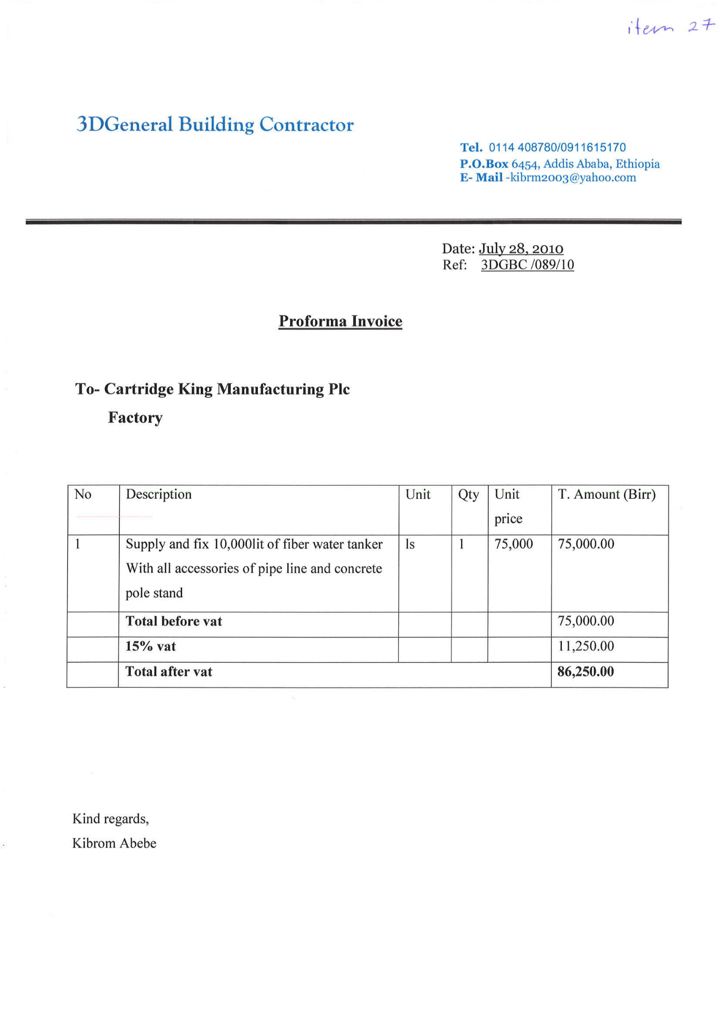
= € 4,295
= € 4,802

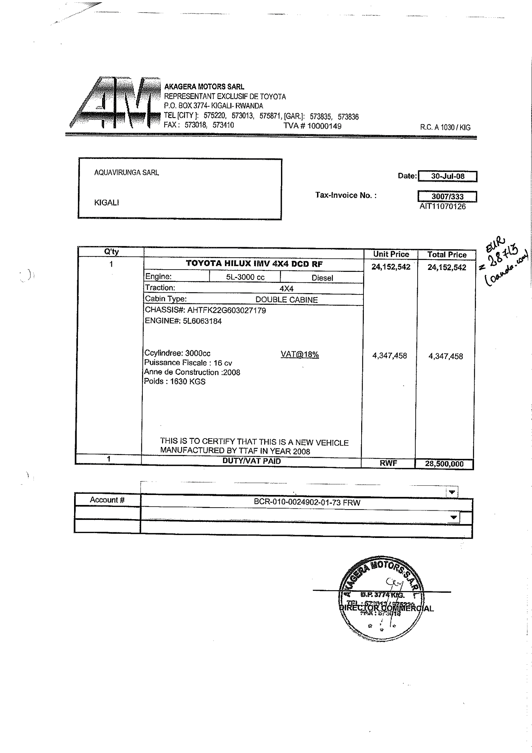

= € 32,715

=€ 27,725
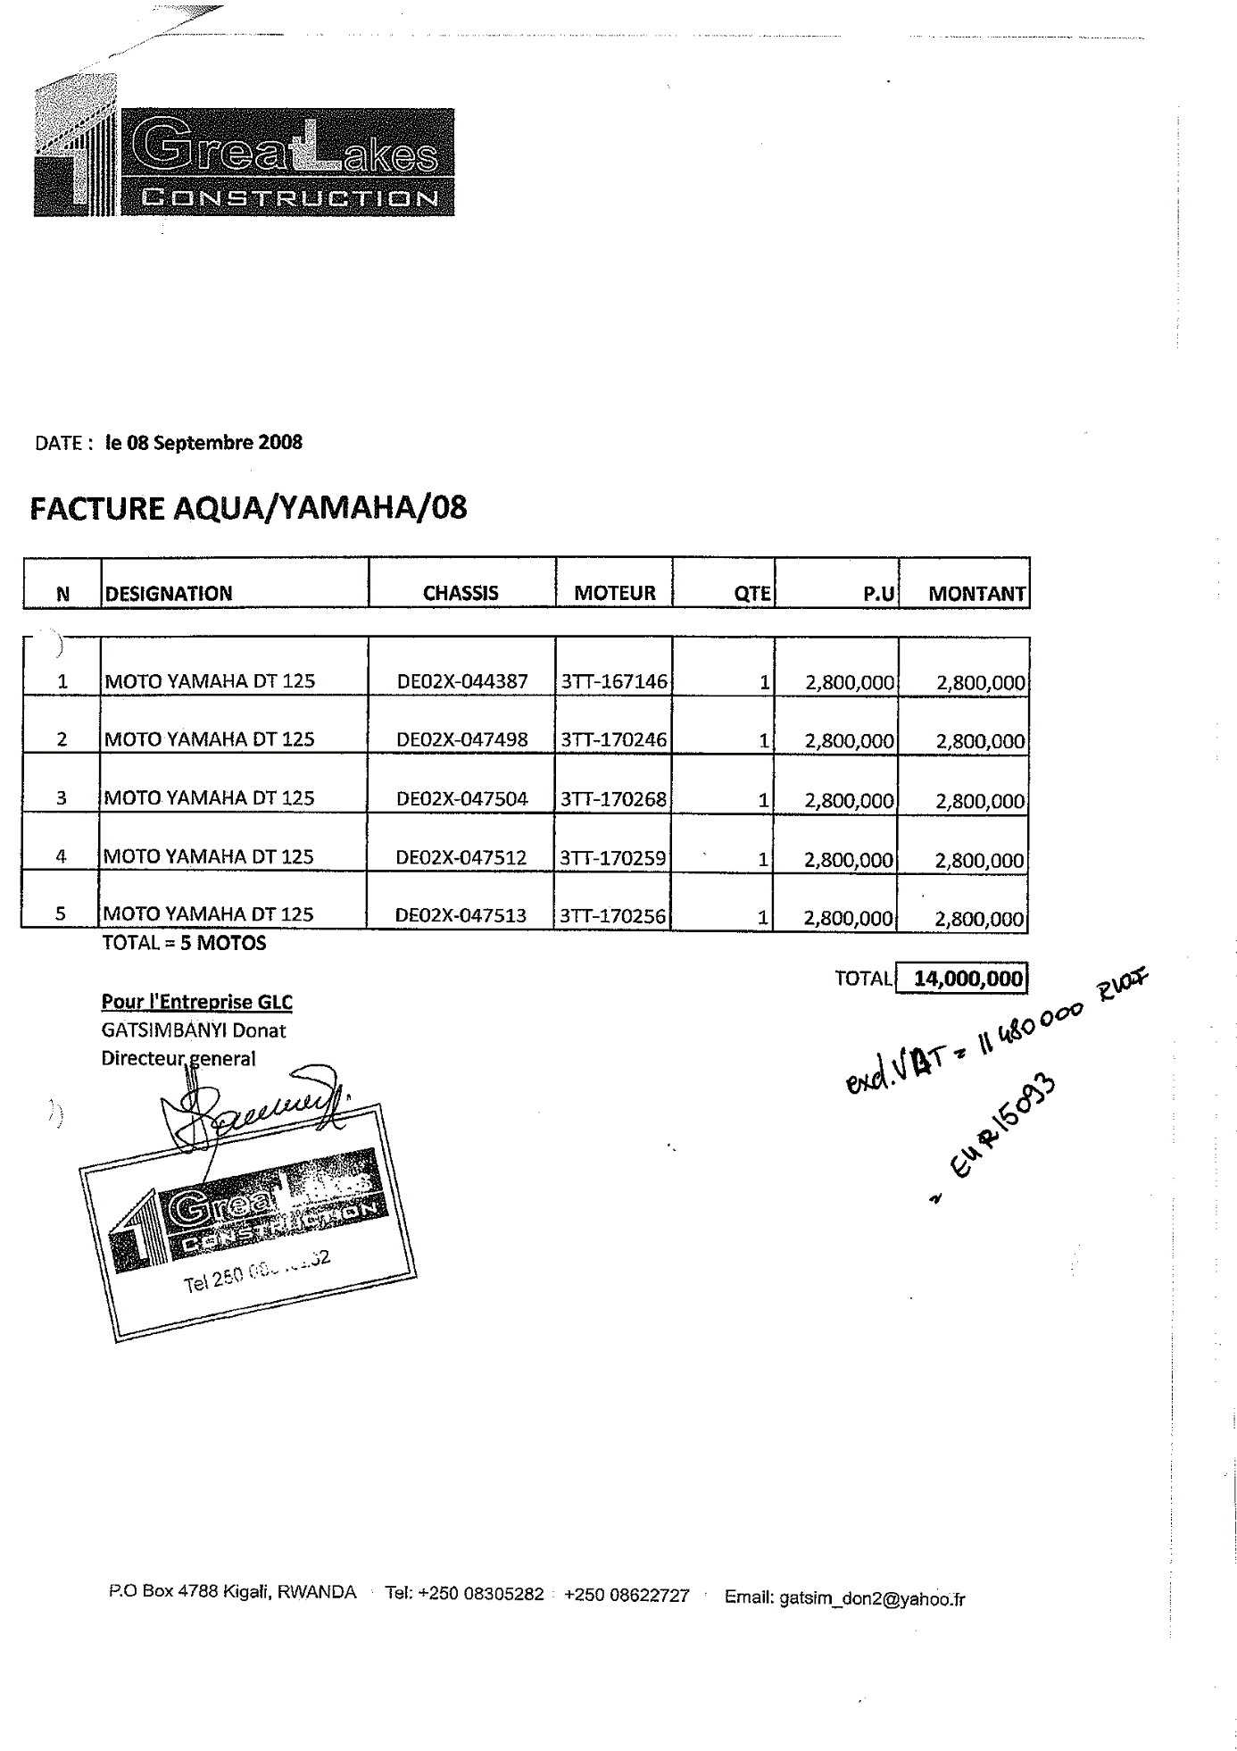

= € 17,696

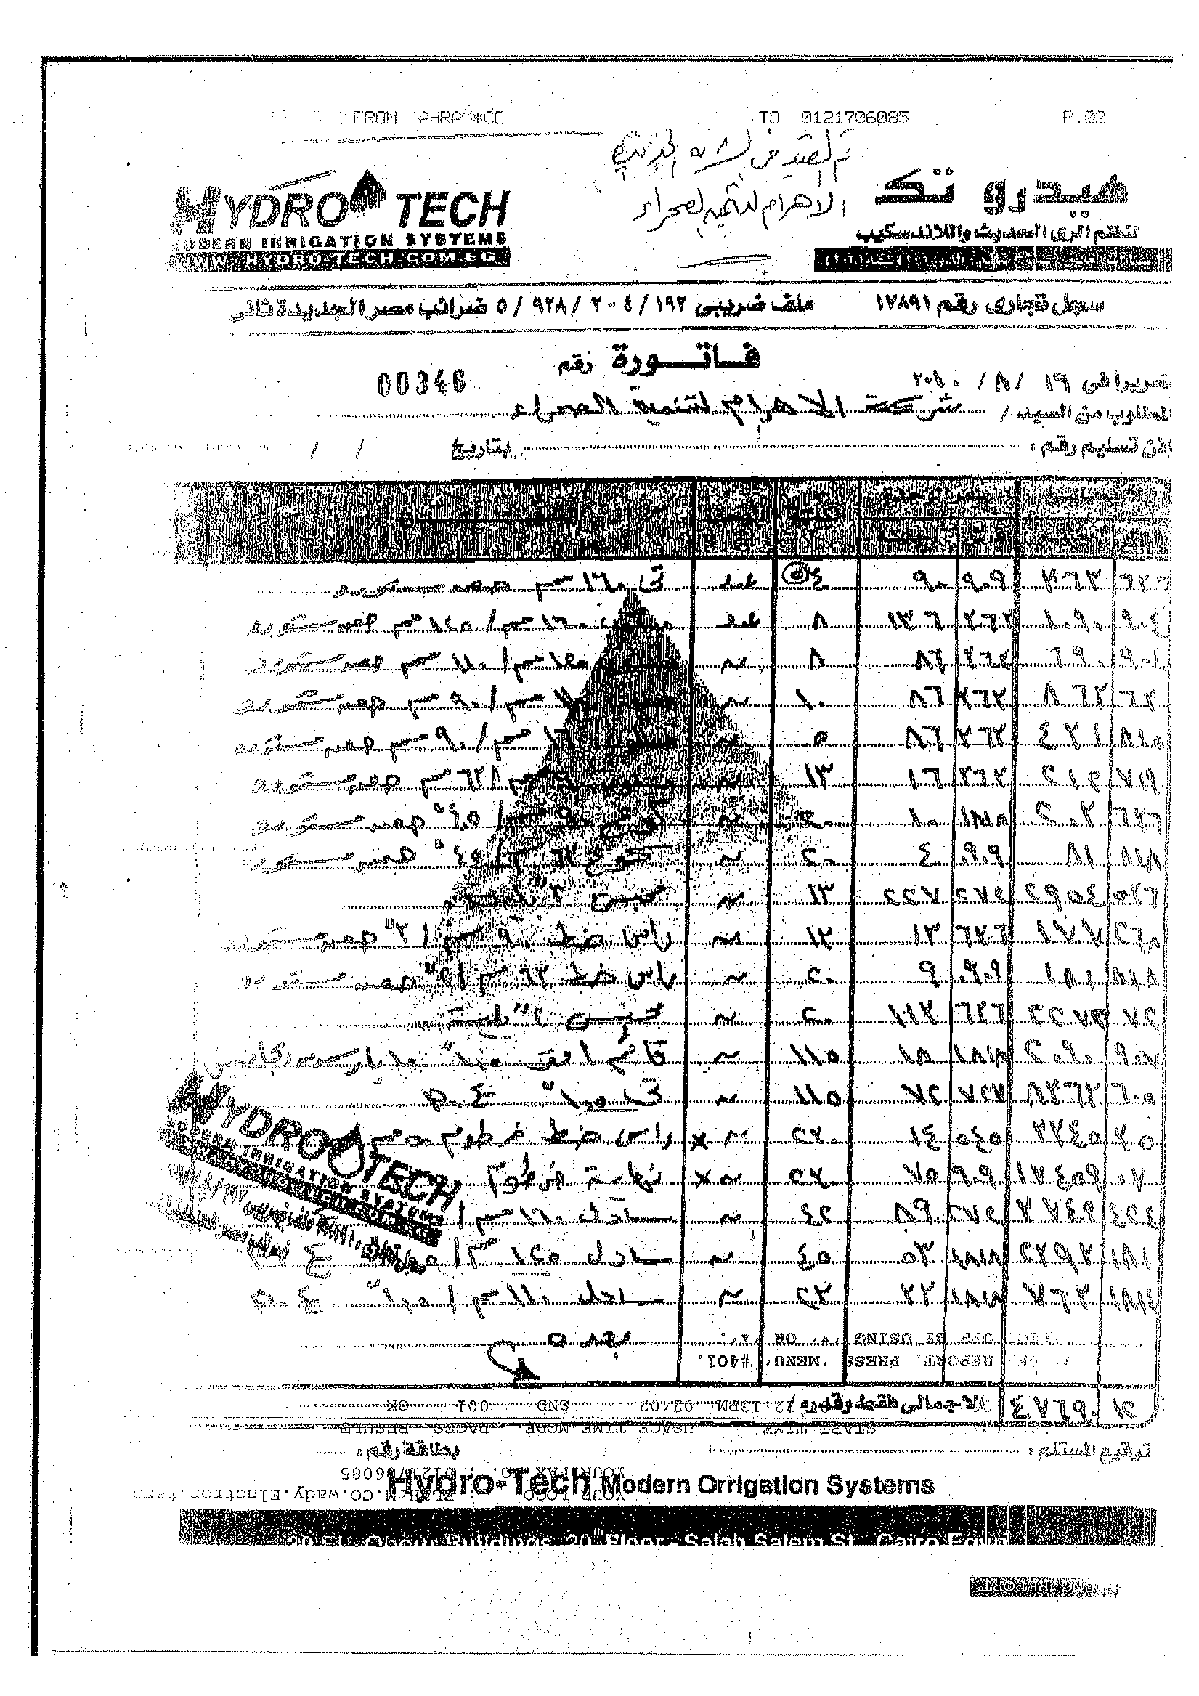

- Filled out protocol of Receipt
MODEL PROTOCOL OF RECEIPT

Project number: | PSI09/UG/22..........
Project title: | Office Uganda..........
Applicant: | Office BV..........
Local Partner: | Travel Uganda..........
Bill of Lading number: | If relevant..........
Packing list: | If relevant..........
Date of this Protocol: | 25-12-2009..........

Applicant and Local Partner herewith state to
- have received at the project site the following goods and related services as specified below; delivered in the framework of the Private Sector Investment programme (PSI).
- have checked these goods upon delivery against the Bill of Lading and state that all goods mentioned therein have been delivered.
- have received goods which appeared to be in good order.
- ensure the correct installation and taking into operation of the goods.
- use the goods exclusively and solely for the implementation of the project and for the project’s objectives.
- have arranged guarantees, which at least comply with accepted standard practices.
- accept full responsibility for these goods and to be liable for their secure storage and maintenance.

Item | Unit | Quantity | Supplier | Description
2.1 | Pieces | 1 | D | Toyota Hilux
2.2 | Pieces | 1 | E | Yamaha motorcycles

For Applicant |  | For Local Partner / JV partner  (not being the Applicant)
Name: | Jan Petersen.......... | Name: | Karugu Mpensa..........
Position: | Director.......... | Position: | General Manager..........
Signature: |  | Signature:
Date: | 25-12-2009.......... | Date: | 26-12-2009..........

PLEASE PAY ATTENTION
- The Protocol of Receipt should reflect reality and cover only those items which have been delivered. Notice that not all items on the RPGS above where included in this Protocol of Receipt, but only those items which have been delivered. For example, the protocol only includes 3 motorcycles while 5 had been requested.

- Filled out Protocol of Production
MODEL PROTOCOL OF PRODUCTION

Project number: | PSI09/UG/22..........
Project title: | Office Uganda..........
Applicant: | Office BV..........
Date of Protocol of Receipt: | 25-12-2009..........
Date of this Protocol: | 25-12-2010..........

Project partners herewith state that:
- the following production and/or sales volume have been realised by the project in the period 01-07-2009 until 01-07-2010. This production and/or sales volume correspond(s) with the production and/or sales targets mentioned in the Administrative Decision.
- for proof of these results, please refer to the document(s), signed by Local Partner and Applicant, in the annex.

Production and/or sales realised

Description | Production / sales in Administrative  Decision | Realised  production / sales
Mtons cashew nut kernels | 25,000 | 400 Mtons

For Applicant |  | For Local Partner / JV partner  (not being the Applicant)
Name: | Jan Petersen.......... | Name: | Karugu Mpensa..........
Position: | Director.......... | Position: | General Manager..........
Signature: |  | Signature:
Date: | 25-12-2010.......... | Date: | 26-12-2010..........
- Statement of expenses example
Appendices to the administrative decision on which the statement of expenses is built

The results

Result 1 | Title of the result: Plan of action concerning factory design and engineering finished
Period | Start date: January 1st 2010 End date: March 31st 2010
Sub results |  | Means of Verification
- Local Partner informed by the Applicant about the administrative decision for the project. |  | - Copy of the grant award letter signed on each page by the Local Partner and implementing partner.
- Establishment of the Joint Venture between the Applicant and the Local Partner according to local law. |  | - Copy of the legally signed Joint Venture agreement, including any related documents such as annexes or side letters in English or translated into English.  - Copy of the registration of the Joint Venture at the Chamber of Commerce, in English or translated into English.  - Copy of the legally signed management agreement between the Applicant and the Local Partner concerning the rights and duties of the project partners with regard to the project, in English.
- Completed factory design and engineering plan. |  | - Copy of the factory design and engineering plan, signed for approval by all Joint Venture partners.  - Copies of required permits.
- Finalised training and maintenance programme and logbook. |  | - Copy of the detailed training programme and logbook for maintenance and production, containing number of people to be trained, subject of training, time planning.
- Progress Report. |  | - The Progress Report elaborating on  the implementation of the project, containing all documents stated in this Result 1 (see  the Model forms in Annex III).

Result 2 | Title of the result: Project infrastructure in place
Period | Start date: April 1st 2010 End date: October 31st 2010
Sub-results |  | Means of Verification
- Main buildings completed and processing line installed and tested with a capacity of 3,500 Mtons cashew nuts in shell resulting in 700 Mtons cashew kernels per year. |  | - Legally signed Protocol of Receipt for all  equipment belonging to result 2.  - Pictures of factory and installed processing line.  - Specification of processing line capacity.  - Report on first test run.
- At least fifty (50) farmers identified, registered and farmers trained. |  | - Copy of register showing the details of the farmer groups registered;  - Updated training logbook: training report drafted by a trainer covering all training subjects; days; number of attendances; names of trainers and five (5) training certificates issued to trainees.
- Long term supply contracts with farmer groups. |  | - Copy of the supply contract with farmers or statement of GTZ that the conditions in  the supply contracts are reasonable.
- Procurement of five hundred (500) Mtons of RCN from trained and organised farmer groups during one campaign. |  | - Copy of procurement records showing name of farmer group or supplier, quantity, delivery date and prices paid.
- Progress Report. |  | - The Progress Report elaborating on the implementation of the project, containing all documents stated in this Result 2 (see  the Model forms in Annex III).

Result 3 | Title of the result: Production of 400 Mtons of cashew kernels for export
Period | Start date: October 1st 2010 End date: March 31st 2012
Sub-results |  | Means of Verification
- Three hundred fifty (350) employees contracted of which at least 175 are female. The salaries are at least two percent (10%) above the minimum wages. |  | - Employment records including name, date of birth, gender, salary and position.  - Copies of one (1) labour contract per position.  - Copy of a one-month payroll.  - Copy of HRM policy document(s).
- Three hundred and ninety-seven (397) employees trained on the job to operate  the factory. |  | - Updated training logbook: training report drafted by a trainer covering all training subjects, all days on which training was actually given and names of trainees and trainers.
- Health care and AIDS prevention programme. |  | - Brochures and attendance list of meetings.
- All hardware belonging to result 3 is purchased. |  | - Legally signed Protocol of Receipt for all equipment belonging to result 3.
- Production of four hundred (400) Mtons cashew nut kernels in a 24 months period. |  | - Legally signed Protocol of Production.  - Copy of sales records.  - Copy of bill of ladings.  - Copy of weekly work plan.
- One hundred percent (100%) of the RCN produced by the factory is traceable upon farmer group level. |  | - Copy of traceability report including the volume procured totally and the volume and quality (nuts per kilo, KOR) per farmer group.
- Implementation plan on BRC and BSCI certification. |  | - Copy of GAP analyses on BSCI and BRC.  - Copy of implementation plan on factory level.
- Plan of action on the production of by products. |  | - Inception Report containing a final and detailed implementation plan regarding the by-products.
- Final Report. |  | - Final Report containing all documents stated in this Result 3 and covering both the implementation of the project and the development and spin-off effects as stated in the grant award letter (see the Model forms in Annex III).

Project budget

PSI contribution | 50%
Budget and Payment schedule
Budget 100% (in €)
 | Result 1 | Result 2 | Result 3 | Total
Project management | 16,800 | 39,000 | 13,000 | 98,800
Other TA related to training | 0 | 0 | 30,000 | 0
Other TA related to legal services | 2,000 | 0 | 0 | 2,000
Other TA related to certification & permits | 6,200 | 0 | 0 | 6,200
Other TA related to Engineering & architecture | 0 | 3,200 | 0 | 3,200
Other TA | 0 | 0 | 0 | 0
Total TA | 25,000 | 42,200 | 43,000 | 110,200
Hardware | 0 | 1,112,405 | 119,097 | 1,231,502
Total | 25,000 | 1,154,605 | 162,097 | 1,341,702
Budget PSI contribution, 50% (in €)
 | Result 1 | Result 2 | Result 3 | Total
Project management | 8,400 | 19,500 | 21,500 | 49,400
Other TA related to training | 0 | 0 | 0 | 0
Other TA related to legal services | 1,000 | 0 | 0 | 1,000
Other TA related to certification & permits | 3,100 | 0 | 0 | 3,100
Other TA related to Engineering & architecture | 0 | 1,600 | 0 | 1,600
Other TA | 0 | 0 | 0 | 0
Total TA | 12,500 | 21,100 | 21,500 | 55,100
Hardware | 0 | 556,203 | 59,549 | 615,751
Total | 12,500 | 577,303 | 81,049 | 670,851
Payment schedule (in €)
 | Result 1 | Result 2 | Result 3 | Total
TA | 12,500 | 21,100 | 21,500 | 55,100
Hardware | 0 | 444,962 | 170,789 | 615,751
Total | 12,500 | 466,062 | 192,289 | 670,851
Project duration
 | Start | End
Result 1 | 1-Jan-10 | 31-Mar-10
Result 2 | 1-Apr-10 | 1-Sep-10
Result 3 | 1-Sep-10 | 31-Mar-12

Hardware list
Item No. | Item | Quantity | Price | Amount  €
 | Result 2
1 | Production plant | 1 | 390,300 | 390,300
2 | Canteen, showers and toilets | 1 | 109,796 | 109,796
3 | Crates, buckets etc | 1 | 4,684 | 4,684
4 | Electricity, building for generator and communication lines | 1 | 85,505 | 85,505
5 | Processing equipment | 1 | 511,031 | 511,031
6 | Chairs, stools | 1 | 5,354 | 5,354
7 | Weighing scales | 1 | 4,035 | 4,035
8 | Moister tester | 1 | 1,700 | 1,700
 | Result 3
9 | Bicycle parking | 1 | 8,232 | 8,232
10 | Weighing bridge + weighing bridge building | 1 | 18,598 | 18,598
11 | House of factory manager | 1 | 32,929 | 32,929
12 | Health and day-care-centre | 1 | 12,348 | 12,348
13 | Car for factory management | 1 | 30,490 | 30,490
14 | Office equipment | 1 | 11,500 | 11,500
15 | Forklift | 1 | 5,000 | 5,000
 | Total |  |  | 1,231,502

