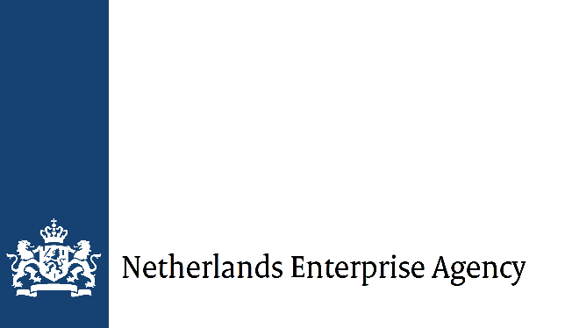

Impact Clusters | Final report
Please use this form to report on the completion of your Impact Clusters project. You can email it to ic@rvo.nl.
In part I, you generally introduce the results.
In part II, you describe the information per activity in more detail. This part is based on the results and activities table you submitted with your application. You can use it for a detailed project monitoring of KPIs. Please include 2 annexes: your financial report and a progress update about the project indicators. For your financial report, please complete the annex 'IC Project budget realisation tool' (Excel). For progress realisation on the indicators, you complete the annex 'IC Indicators' (Word). You can download both annexes from the Impact Clusters webpage.
In part III, you describe the final results, lessons learnt and collaboration within the impact cluster. Here, you can also add information to part I.
Name of impact cluster (project title)
Project number
Start and end date of the reporting period
dd-mm-yyyy
Date of submission
dd-mm-yyyy

Part I
General narrative
Please describe the progress achieved in the reporting period. You can give detailed information per activity in part II. (500 words max)

Part II – Specific reporting on activities and KPIs
Copy all activities and subresults
Coordination module results

Activity | Subresult (KPI) | Means of Verification (MoV) | Lead partner per activity | Progress on KPIs | Type of MoV submitted
- Copy from the results and activities table | 1.1  1.2  And so on. | 1.1.1  1.2.1  And so on. |  | And so on. | And so on.
2. | 2.1  2.2  And so on. | 2.1.1  2.2.1  And so on.

Coordination module narrative results
Explain the following:
- the final results per activity;
- the challenges and obstacles encountered during the implementation;
- any deviations from the approved subsidy application's original results and activities table.
(300 words max)

Studies module results

Activity | Subresult (KPI) | Means of Verification | Lead partner per activity | KPI achieved (y/n) | MoV submitted  (y/n)
Copy from the results and activities table

Studies module narrative results
Explain the following:
- the final results per activity;
- the challenges and obstacles encountered during the implementation;
- any deviations from the approved subsidy application's original results and activities table.
(300 words max)

Demonstrations modules results

Activity | Subresult (KPI) | Means of Verification | Lead partner per activity | KPI achieved (y/n) | MoV submitted  (y/n)
Copy from the results and activities table

Demonstrations module narrative results
Explain the following:
- the final results per activity;
- the challenges and obstacles encountered during the implementation;
- any deviations from the approved subsidy application's original results and activities table.
(300 words max)

Knowledge transfer module results

Activity | Subresult (KPI) | Means of Verification | Lead partner per activity | KPI achieved (y/n) | MoV submitted  (y/n)
Copy from the results and activities table

Knowledge transfer module narrative results
Explain the following:
- the final results per activity;
- the challenges and obstacles encountered during the implementation;
- any deviations from the approved subsidy application's original results and activities table.
(300 words max)

Communication module results

Activity | Subresult (KPI) | Means of Verification | Lead partner per activity | KPI achieved (y/n) | MoV submitted  (y/n)
Copy from the results and activities table

Communication module narrative results
Explain the following:
- the final results per activity;
- the challenges and obstacles encountered during the implementation;
- any deviations from the approved subsidy application's original results and activities table.
(300 words max)

Part III – Extra project completion information
Please only complete the topics that apply to your project.
Relevant developments within the context of your impact cluster project (in the country and sector) that influenced the final results.
(200 words max)
Collaboration within the cluster
- Are or were all partners involved in regular cluster meetings? How were they organised?
- Did specific partners encounter difficulties or setbacks? How did the cluster deal with these?
- Did all parties have the same expectations about the project?
- Was everyone committed to the project?
- Did any problems occur while organising activities and making appointments?
- Was it easy to communicate via email/telephone/letter and in person?
- Did all parties have enough human resources available?
(200 words max)
Lessons learnt
- How did you deal with identified risks?
- What lessons did you learn/were learnt about creating sustainable and scaling impact?
- How can local ownership and local support best be organised?
- Were the budget and planning realistic?
- What were the success factors of this project?
- What were the pitfalls?
- Any other lessons learnt?
(200 words max)
Impact beyond the project period
- How do you foresee scaling up the project after the project period?
- Discuss the actions that were undertaken or should be taken to ensure the project's sustainability.
(200 words words)
Cooperation with local stakeholders and beneficiaries
(200 words max)

Impact on private sector development ecosystem
- To what extent do local Micro, Small and Medium Enterprises (MSMEs) use the new or improved resources and capacity to perform better (more inclusive, social, sustainable and profitable)?
- To what extent do essential stakeholders in the sector use a better network, new knowledge and improved skills to:
a) provide better services to (future) MSMEs?
b) improve policies, regulations and plans that enable sustainable private sector development and address local challenges?
- To what extent does this project contribute to the private sector's performance? Or align with other Dutch interventions for private sector development?
(200 words max)
Cooperation with the Netherlands Enterprise Agency (RVO) and the Netherlands embassy
- What went well?
- What could be improved?
- Did you make use of NL Branding support? If not, why not?
(200 words max)
Investment and trade opportunities
- Has a change occurred in investment and/or trade opportunities for the cluster members? If so, please explain.
- Has a change occurred in investment and/or trade opportunities for local companies? If so, please explain.
(200 words max)

Contribution to policy themes (final report only)
To which of the following themes has the project contributed? Please tick the boxes below. You can give more than one answer.
☐ Climate change adaptation
☐ Climate change mitigation
☐ Transition to a circular economy
☐ Sustainable usage and protection of water and marine resources
☐ Prevention of and combatting pollution
☐ Protection and restoration of biodiversity and ecosystems
☐ Conflict sensitivity
☐ Responsible Business Conduct (RBC)
☐ Digitalisation
☐ Gender equality
☐ Innovation
☐ Youth employment
☐ None of the above
For each of the policy themes you marked, please answer the following questions:
- How did this project contribute to this policy theme?
- What specific results did the project achieve?
- To what extent did these results contribute (extra) to private sector development?

Name of lead applicant representative
Location/date
Signature
Thank you for completing this form. You can email it to ic@rvo.nl.

Would you like to get support through the Netherlands Branding team? Contact your PSD coach about the possibilities.

