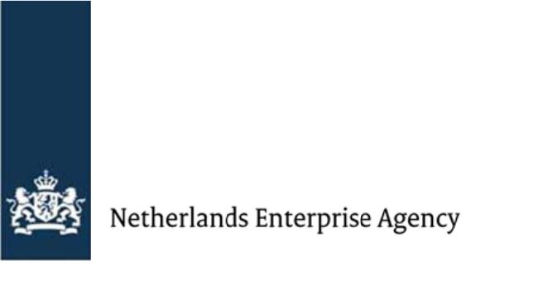

Final report for the Fund against Child Labour (FBK)

Project B

Introduction

- Your final report summarises the B project results and the total costs. We will determine the final subsidy amount based on this report.
- Complete your report and all annexes in English.
- Please send your report with the annexes mentioned below to fbk@rvo.nl:
  - Agreed MoV's per result;
  - Results sheet;
  - Financial budget tool; and
  - Management Statement.
- Send us the final report according to the (amended) grant decision date.
- The lead party must sign the final report.
Read all questions first before you answer them to avoid repetition.

General information

Project title
Click or tap here to enter text.

Reference number
FBK Click or tap here to enter text.

Name of the lead party
Click or tap here to enter text.

Names of the project partners
Click or tap here to enter text.

Project country/countries
Click or tap here to enter text.

Sector(s)
Click or tap here to enter text.

Start date of the project
Click or tap here to enter text.

End date of the project
Click or tap here to enter text.

Reporting periode
Click or tap here to enter text.

Narrative and summary

- Summarise the overall project. Clearly state how this project has contributed to FBK's primary goal of ending child labour. We will also use this summary for external communication purposes.
Click or tap here to enter text.

- Describe how this project has addressed the root causes of child labour as you identified in project A or the project proposal.
Click or tap here to enter text.

- Describe how gender was part of the project approach.
Click or tap here to enter text.

- Describe how this project has addressed the due diligence gaps you identified in project A or the project proposal.
Click or tap here to enter text.

- Describe how the project addressed other CSR risks you identified besides child labour in your project proposal. Clearly describe if and how the project results contributed to reducing these CSR risks.
Click or tap here to enter text.

- What are the most important lessons you have learnt? What would you have done differently? And how will you incorporate these lessons in future projects?
Click or tap here to enter text.

Project achievements

- Complete the Results sheet. Use the tab FBK Results Project B to report on Project B's progress and project results. Use the tab FBK indicators to report on the project indicators, including the mandatory FBK indicators. If applicable, report on your project-specific indicators.

- Refer to the result sheet and describe the project activities and the results. Also, describe how the results contribute to the indicators you reported on.
Click or tap here to enter text.

- If your result sheet states that you did not meet specific targets, describe in more detail why not. How did you ensure that you still achieved the overall goals?
Click or tap here to enter text.

Engagement & cooperation

- Describe how you involved the target group(s) in the project and how you considered their need(s). How did this influence the project's overall results? If available, include documentation or (positive and critical) feedback from the target groups. For example, you can collect feedback through surveys, interviews or focus-group discussions with the beneficiaries.
Click or tap here to enter text.

- Describe how you involved girls and women in your project. State how you ensured their interests throughout the project and its outcomes. If available, include documentation or feedback. Also, describe any lessons learnt and how you will carry these out in follow-up activities or new projects.
Click or tap here to enter text.

- Describe how the partners worked together during the project. For example, did it go well? Were there changes in partners? Did you encounter any problems? Indicate how each partner contributed to the final project results.
Click or tap here to enter text.
- Describe how you involved other actors in the activities. For example, other supply chain actors, community-based organisations or local governments. State what challenges you encountered in doing so. Also, state how these actors impacted the project results.
Click or tap here to enter text.

- What are the most important lessons you have learnt about engagement and collaboration? What would you have done differently? And how will you incorporate the lessons in future projects?
Click or tap here to enter text.

Context & Risks

- Describe project-significant (external) factors, events and changes that have influenced the project positively or negatively.
Click or tap here to enter text.

- Explain your efforts to reduce internal or external risks and how these risks have impacted the project results. Also, refer to the implementation risks you identified in the project proposal.
Click or tap here to enter text.

- What are the most important lessons you have learnt on reducing risks? What would you have done differently? And how will you incorporate these in possible future projects?
Click or tap here to enter text.

Company measures: due diligence process

- Describe to what extent your company has integrated the 6 due diligence steps. If you still need to take steps, state which ones.
Click or tap here to enter text.

- Did you develop a sustainable business case? What motivates you to continue or stop developing a sustainable business case in the long term?
Click or tap here to enter text.

- Describe your company's goals for due diligence for the next 5 years. State the activities you will carry out to reach these goals.
Click or tap here to enter text.

Sustainability

- To understand the sustainability of this project, describe how you included project sustainability in the design and implementation. Also, explain how the project can continue and how results will be maintained now the funding has ended. Consider the following levels in your answer:
1. Financial 2. Target groups 3. Cooperation with partners and stakeholders
Click or tap here to enter text.

- Indicate how someone can replicate or scale up this project. What is needed to do so?
Click or tap here to enter text.

- Describe your company’s goals for the next 5 years for ending child labour. State the activities you will carry out to achieve these goals.
Click or tap here to enter text.

Financial reporting

- Fill out the costs per result in the Financial budget tool. The costs must correspond with the results and budget following the (amended) grant decision. We will determine the final subsidy amount based on these actual costs.

- If the total costs (per budget line per result) differ from the approved budget in the (amended) grant decision by more than 25% and this change is higher than €2,000, please explain the difference below. Also, mention how this change has influenced the project.
Click or tap here to enter text.

Media and Communication

- Have you developed a specific result or case story (video, pictures or other communication materials)? Please include these in an attachment or provide a link below.
Click or tap here to enter text.

Declaration and signatures

By signing this final report, the lead party declares that the information in this report (and its annexes) is accurate and complete and fulfils the conditions agreed in the (amended) grant decision.
Organisation
Click or tap here to enter text.

Name
Click or tap here to enter text.

Position
Click or tap here to enter text.

Date
Click or tap here to enter text.

Signature

The mandatory FBK indicators are: - The # and % of children aged 5 until 17 engaged in child labour within the geographical unit of the project (factory/community/region) by gender and age; - The # and % of children that face a high risk of child labour within the geographical unit of the project by gender and age.

