Background

In December 2021, Peninsular Malaysia experienced severe flooding. At the Malaysian government’s request, the Netherlands deployed a Disaster Risk Reduction (DRR) team in September 2022 to assess the situation. The team identified a strong national ambition to transition from reactive to proactive flood and drought management, though external input seemed needed to achieve this shift.

The DRR team proposed a pilot project to explore strategies blending structural (grey and green) and non-structural measures. Sabak Bernam, part of the Bernam river basin, was selected for its mix of agriculture, villages, and peatland but faces stagnating socio-economic development. Potentially a second pilot location will be added to the scope around the Klang river.

Selangor state aims to boost the region through eco-tourism and sustainable agriculture, requiring a unified vision that integrates economic growth with improved flood and drought resilience. Both federal and state governments are exploring innovative nature-based solutions like coastal reservoirs and sponge city concepts to enhance disaster preparedness and water management. Now that Malaysian stakeholders seem ready to bring this initiative to the next level, additional guidance from the DRRS programme is likely to be effective.

Key Malaysian partners in this are the Ministry for Energy Transition and Water Transformation (PETRA), the National Water Research Institute of Malaysia (NAHRIM) which is an agency under the oversight of PETRA tasked with research and development related to water resources and hydrology in Malaysia and DID (Division of irrigation and Drainage).

Overall deployment specifications
  - Objectives and scope
The objective is to support the Malaysian stakeholders (NAHRIM, PETRA, DID and possibly others), in their process towards vision development for integral flood resilience and water security, leading to implementing an integrated landscape approach based on nature based solutions in the pilot zone(s).
The scope is continuously being revised and improved. Leading terms will be the support to develop a vision and integrated approach and to allow nature based solutions to be the foundation of any solution process.

  - Activities

- Analysis of the reports and data sources available.
- Coordination with Malaysian stakeholders, EKN, RVO and between the individual DRRS team members. Both before, during and after deployment.
- Organize an extensive workshop in Malaysia involving all relevant levels of government and institutions. This includes organizing structure and set-up of workshop upfront of visit to Malaysia.
- Provide input to write and finalize the report after return from the deployment.

  - Deliverables
- Workshop in Malaysia aiming to facilitate:
  - A joint vision for the pilot area(s)
  - Agreement on main problems to address in the pilot catchments
  - Agreement on shared goals for the catchments
  - Development of an appropriate governance structure
- Dissemination through relevant (social) media to local stakeholders and DRR community
- Final DRRS report, based on DRRS template (to be provided), with the Malaysian stakeholders as primary audience.

Required expertise
Based on the available information, the selected team leader should ideally comply with the following description:

General requirements (applicable for all for all team members):
- Able to rapidly assess situations and data and provide conceptual and practical solutions;
- Experience in and knowledge of the local/regional context;
- Ability to be a relevant sparring partner for the local officials and to provide feedback on the existing plans and ideas, as well as provide input for suitable alternatives;
- Excellent presentation and reporting skills in English;
- Good communication skills in English;
- Familiarity and practical experience with complex (governance) systems;
- Experience with International Financial Institutions (IFIs) is an asset.

Team leader (TL) requirements: (already recruited in scoping phase)
- Senior expert in water related issues with knowledge of the regional context
- Long term experience as a project/team-leader;
- Ability to act as a focal point for the DRRS coordination team;
- Ability to lead the team, coordinate with the Embassy, facilitate group discussions, present overall conclusions and recommendations, coordinate reporting & responsible for a high quality advice;
- Ability to formulate a strategy to deal with the various factors in the study area;
- Possess a strong sense of political-governmental sensitivity.

Integrated water resources management expert:
- Senior expert on IWRM;
- Senior expert on interpolation and extrapolation of hydrological data;
- Experience with Nature Based Solutions.

River hydraulics and hydrology expert: (already recruited in scoping phase)
- Senior expert on hydrological/flood modelling;
- Senior expert on interpolation and extrapolation of hydrological data;
- Experience with Nature Based Solutions.

Governance expert:
- Senior expert on governance models able to oversee and explain the different models applied in various countries;
- Expertise on the region/country and its governance model, the various institutions and their responsibilities;
- Access to local relevant stakeholders and institutions.

Socio-economic development expert:
- Senior expert socio economic development models and pathways;
- Experience in economic development with regard to spatial planning on a strategic level in the phase of vision development for a region;
- Expertise on the region/country;
- Access to local relevant stakeholders and institutions.

Landscape architecture expert:
- Senior landscape architect with experience in Nature-based Solutions and water related challenges
- Experience with landscape approaches, vision development and facilitating and organising workshops related to these themes
- Experience and/or familiarity with hydrological integrated design, adaptivity, ecological restoration, stakeholder process and governance structures;

Budget
DRRS-Programme is a facility that supports foreign governments in preventing water-related disasters.

Each individual expert is expected to provide an all-inclusive detailed budget, including the fees and expected expenditures in order to conduct this assignment. This should be presented as a total budget for this assignment, in line with our Terms and Conditions and budget format which will be shared separately.

- Timing
The initial period of this DRRS intervention will be from April 2025 until August 2025.

Table 1: roles and time input
Role | Input [days]
TL-NBS expert | N.A.
Integrated water resources management expert | 12
River hydraulics and hydrology expert | N.A.
Socio-economic expert | 12
Governance expert | 12
Landscape architecture expert | 12
Additional profile(s) | Tbd

Any usage of time by other persons within the same contracted organization is to be agreed upon by RVO in writing.

The indicative timeline in order to publish the joint publication is the following:

- April 2025 Kick-off with team;
- May 2025 Deployment DRRS team to Malaysia;
- June 2025 Finalization of DRRS report and dissemination to stakeholders;

- Contracting and reporting
Contracting of the experts will be conducted by Netherlands Enterprise Agency (RVO.nl). All documents should be sent to drrs@rvo.nl and gertjan.vanderende@rvo.nl.

Annex A: Official request 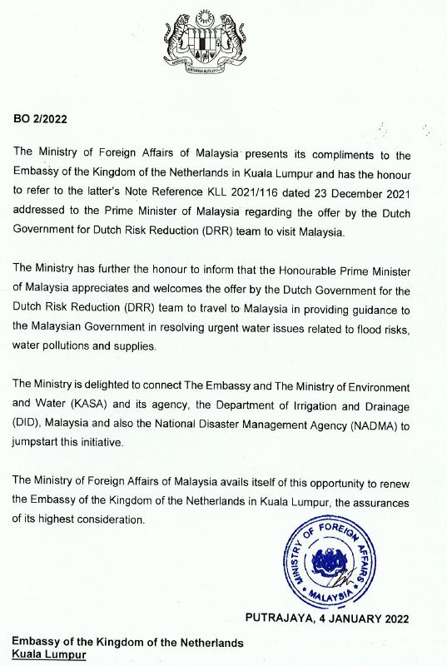

Annex B: DRRS programme
Many countries around the world face severe water threats. Often, these countries are in urgent need of expert advice on how to prevent a disaster or how to recover from a calamity. For instance, when a country has been struck by severe flooding and the first emergency relief workers have gone, the need for advice on how to build a sustainable and safer water future arises.

To meet these needs with a swift response, the Dutch government (Ministry of Foreign Affairs and the Ministry of Infrastructure and Environment) has initiated the Dutch Risk Reduction Team (DRR-Team). This team of experts advises governments on how to resolve urgent water issues related to flood risks, water pollution and water supply, to prevent disasters or to rebuild after water related disasters. The DRR-Team enables a foreign government to take action on the basis of sound advice and expertise. The DRR-Team is coordinated by the Netherlands Enterprise Agency (RVO.nl).

