TERMS OF REFERENCE FOR INDIVIDUAL CONSULTANTS
Title  Remote Sensing Study for Water Resources in Taizz City | Funding Code | Type of engagement  Consultant | Duty Station:  Home Based
Purpose of Activity/Assignment:
Taizz City is the third most populated city in Yemen after Aden and Sana’a, located in southwestern Yemen. It is home to approximately 635,900 people, including around 161,000 Internally Displaced People (IDPs). The city has been facing chronic water scarcity issues since the 1970s due to the limited groundwater resources and high population density.
The main government entities in charge of water resources are the National Water Resources Authority (NWRA), the Ministry of Water and Environment (MWE), the Ministry of Agriculture and Irrigation (MAI), and the Local Water and Sanitation Corporations (LWSCs). The NWRA, established in 1995, is a decentralized government agency with wide ranging legal powers to implement water laws and regulations, allocate water rights, approve permits for drilling wells, and undertake various other water resources management functions. The MWE, established in 2003, is the cabinet-level supervisory body that brings the water sector as a whole, and water management in particular, under the purview of the central government, thus facilitating the allocation of necessary funds. Yet, the responsibility of water use for irrigation purposes falls under the MAI, which shares jurisdiction over surface spate water with the MWE. The provision of urban water and sanitation services is the responsibility of the LWSCs, which have a board, formed with the representatives of central and local government and community The Taizz LWSC was established in 2001. The Taizz LWSC coverage area used to receive water from approximately 86 wells located in four main wellfields on both sides of the frontline. With the frontline located in the north of Taizz City, the LWSC is unable to provide water to some areas. While each of the conflict areas has its own wells, there are significant challenges with generators and fuel supply as well as damage caused by the conflict. Taizz is also one of Yemen’s main industrial hubs. To provide water to the factories, a desalination plant was built near Al Mokha, with the view to also provide partial supply to the city of Taizz. The plant was destroyed in 2016. The sanitation infrastructure consists of the sewer network, wastewater pump stations, and a Wastewater Treatment plant (stabilization ponds). There are strong indications that some raw wastewater is used by farmers for agricultural purposes.
The water and sanitation sector, including the infrastructure, has sustained considerable damage during the years of conflict. According to the Yemen WASH Cluster, before the conflict, the water network covered around 72% of the population of Taizz City, in mid-2025 this coverage was down to 29%. The average water supplied to the city amounts to 23 liters per person per day. and frequent service interruptions can last for more than one month at a time. In July 2025, more than 600,000 people in Taizz City had no safe or reliable access to water and people have to resort to unsafe sources for drinking water or pay high prices for water trucking. The challenges in water supply are one of the causes for Taizz having the largest numbers of reported cholera cases in 2025.
There is a lack of qualitative and quantitative information of groundwater resources and hydro-meteorological data in general in Yemen due to poor data collection, storage and management. The conflict, which started in 2015 has increased the challenges due to access, destruction of monitoring stations and data sharing between the north and the south. Before the conflict started, explorations of water sources in areas around the city were conducted. Several attempts to bring water from the rural areas to the city were unsuccessful due to either limited compensation to the rural communities or because of conflicts with rural communities.

To work towards addressing the water supply gap of Taizz City and the immediate surroundings more information needs to be gathered about the potential locations of additional water resources.
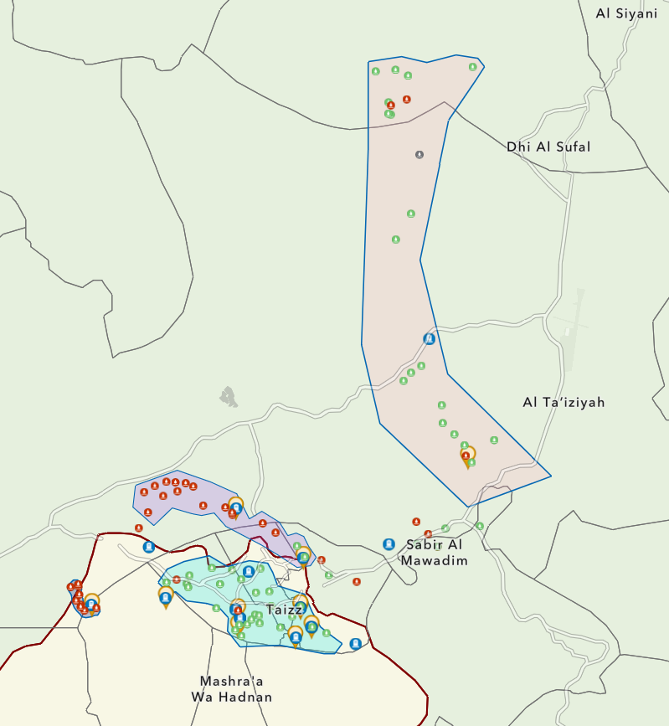
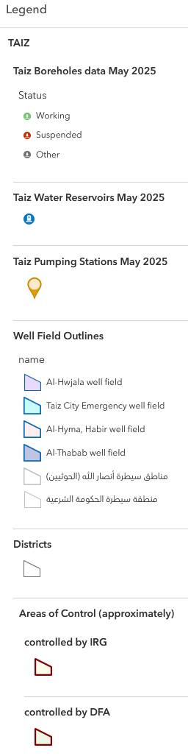

Scope of Work:

Objective
The objective of this study is to assess the groundwater resources that can be used for the water supply of Taizz City through remote sensing and GIS analysis to produce preliminary groundwater potential maps. The geographical area for these studies will cover the whole Upper Wadi Rasyan to be used in a different project to develop an integrated water resources management plan for Taizz City. The expert will then identify high potential areas for further groundwater investigations and suggest appropriate and realistic methods to carry out these investigations.
All data used to carry out the tasks, including geospatial data, models and maps created, will be handed over to the MWE and UNICEF at the end of the contract to be used in future projects.
The study shall include - but is not limited to - the following components:
Assessment of the Upper Wadi Rasyan watershed: Develop a preliminary groundwater potential map using GIS analysis of existing datasets, remote sensing for groundwater potential and groundwater pollution indicators. . . Identify high potential areas for further groundwater investigations and suggest appropriate and realistic methods to carry out these investigations.

Scope of Work
The assignment will focus on conducting a preliminary assessment of the water resources in Taizz City and its immediate surroundings to identify areas with groundwater resources which could be developed for Taizz City.
To ensure a robust and data-driven analysis, the assessment should integrate Geographic Information System (GIS) tools, mapping technologies, and other spatial analysis tools to visualize and categorize potential water resources for Taizz City. This approach will enable informed decision-making and stakeholder engagement.

Child Safeguarding
Is this project/assignment considered as “Elevated Risk Role” from a child safeguarding perspective?

YES NO If YES, check all that apply:

Direct contact role YES NO
If yes, please indicate the number of hours/months of direct interpersonal contact with children, or work in their immediately physical proximity, with limited supervision by a more senior member of personnel:

Child data role YES NO
If yes, please indicate the number of hours/months of manipulating or transmitting personal-identifiable information of children (name, national ID, location data, photos):

More information is available in the Child Safeguarding SharePoint and Child Safeguarding FAQs and Updates

Budget Year: | Requesting Section/Issuing Office: |  | Reasons why consultancy cannot be done by staff:
2026 | WASH |  | Specialized Skills needed (remote sensing)
Included in Annual/Rolling Workplan: Yes No, please justify:

Consultant sourcing:  National International Both  Competitive Selection:  Advertisement Roster  Single Source Selection (Emergency - Director’s approval) |  |  |  |  | Request for:  New SSA – Individual Contract  Extension/ Amendment
If Extension, Justification for extension:

Supervisor: |  | Start Date: |  | End Date:
Chief of WASH |  | 24.11.2025 |  | 15.12.2025

Work Assignments Overview | Deliverables/Outputs | Delivery deadline | Estimated Budget
1 Scoping – Inception Meeting  The inception meeting shall serve to agree on the modalities and methodologies used in carrying out the tasks. These include:  - Identification of the key individuals of UNICEF to be involved in the different tasks and how they have to be involved.  - Handover of available (GIS/Well) datasets, reports, etc.  - Discussion and agreement on details of the methodology that will be used to carry out the assessments.  - Discussion and agreement on workplan, that outlines key activities, timelines, responsibilities, and deliverables, ensuring alignment with the study's objectives and methodologies. | Inception Meeting Minutes  Detailed minutes of the Inception Meeting including decisions taken and action points agreed. | 1 week after Inception Meeting
2 Assessment of Water Resources  • Using GIS analysis of available datasets and remote sensing, assess the available surface and groundwater resources in the Upper Wadi Rasyan watershed and produce groundwater potential maps including groundwater pollution proxies, as well as a GIS database containing all data used.  • Identify high potential areas for further groundwater investigations and suggest appropriate and realistic methods to carry out these investigations, with a focus on potential fieldwork operations. | Final Groundwater Assessment Report  Documenting findings and recommendations as outlined in the scope The scoping report shall include both technical and geospatial analysis:  - Groundwater potential maps for Upper Wadi Rasyan watershed, including all geospatial GIS data, models and maps developed by the expert.  - Map (GIS Layer) with high potential areas for further groundwater investigations as well as suggestions of appropriate and realistic methods to carry out these investigations.  - Written details of the methodology used for the development of the maps and the analysis of these. | 1 month after signing of contract. | 15 working days

Estimated Consultancy fee
Travel International (if applicable) | n/a
Travel Local (please include travel plan) | n/a
DSA (if applicable) | n/a
Total estimated consultancy costs
Minimum Qualifications required*: | Knowledge/Expertise/Skills required *:
Bachelors Masters PhD Other  Enter Disciplines  - Integrated Water Resources Management (IWRM)  - GIS and Remote Sensing  - Applied Earth Observation and Geo-Analysis  - Hydrogeology / Hydrology  - or equivalent | - Experience of at least 7 years’ in remote sensing for water resources or similar tasks.  - Experience in report writing and analytical skills.  - Experience in working on water studies in fragile contexts.  - Other attributes e.g. analytical skills, communication and negotiation skills.  - Experience in working with the UN and the government in Yemen will be an advantage.
*Minimum requirements to consider candidates for competitive process | *Listed requirements will be used for technical evaluation in the competitive process
Evaluation Criteria (This will be used for the Selection Report (for clarification see Guidance)
A) Technical Evaluation (e.g. maximum 75 Points) B) Financial Proposal (e.g. maximum of 25 Points)

A) Technical Evaluation
Category | Maximum Points
Educational background | 10
Relevant experience in remote sensing for water resources assessments | 20
Relevant experience in development of groundwater potential maps | 20
Proven high-quality report writing in English | 10
Quality of proposed methodology | 15
Total Technical | 75

B) Financial Proposal (maximum 25 points)
The maximum number of points will be allotted to the lowest fee proposal and compared among those invited / applicants which obtain the threshold points in the evaluation of the technical component. All other fee proposals will receive points in inverse proportion to the lowest price.

Administrative details:  Visa assistance required:  Home Based Office Based: | If office based, seating arrangement identified:  IT and Communication equipment required:  Internet access required:
Request Authorised by Section Head | Request Verified by HR:
Approval of Chief of Operations (if Operations): Approval of Deputy Representative (if Programme)

______________________________________ ____________________________________

Representative (in case of single sourcing/or if not listed in Annual Workplan)

Costs indicated are estimated. Final rate shall follow the “best value for money” principle, i.e., achieving the desired outcome at the lowest possible fee. Experts will be asked to stipulate all-inclusive fees, including lump sum travel and subsistence costs, as applicable.

Payment of professional fees will be based on submission of agreed deliverables. UNICEF reserves the right to withhold payment in case the deliverables submitted are not up to the required standard or in case of delays in submitting the deliverables on the part of the expert

