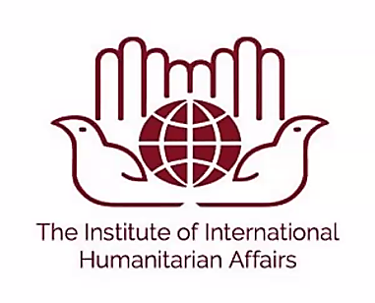

Humanitarian Preparation and Response Program (HUPREP)
for Professionals Working in or with the Humanitarian Sector

The Hague, December 17 - December 18

The Institute of International Humanitarian Affairs (IIHA), Fordham University
Netherlands Enterprise Agency (RVO)
Netherlands Red Cross


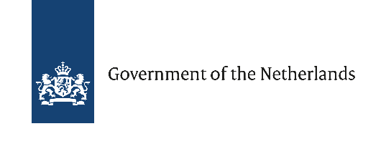
Training Invitation: Humanitarian Preparation and Response Program (HUPREP)

RVO/DRRS and the Netherlands Red Cross (NRK) are organizing a two-day training to provide professionals with the essential knowledge and practical tools to navigate the complexities of humanitarian work. Whether you're new to the sector or have prior experience, you will gain the skills needed to operate effectively within humanitarian settings.

About the Training
As a humanitarian worker or a technical expert working in or with the humanitarian sector, you bring critical knowledge and experience to partners in the humanitarian field. To anchor this experience in a sustainable way in humanitarian environments, it’s essential to align with the humanitarian principles, systems and actors that shape international response. Understanding the systems, principles and dynamics of the humanitarian sector is key to delivering meaningful, coordinated impact.

The Humanitarian Preparation and Response Program (HUPREP), held on December 17 & 18, 2025 in The Hague, is designed specifically for DRRS roster members and others working for the humanitarian sector.

Led by experienced humanitarian practitioners and expert facilitators from the Netherlands Red Cross, Fordham University’s IIHA, and the Netherlands Enterprise Agency (RVO), this intensive two-day training explores the structure of the humanitarian system, international legal frameworks, emerging global challenges and how you can effectively navigate the humanitarian architecture. Through interactive sessions and real-world case studies, you'll connect your technical expertise to the wider humanitarian landscape.

Why Join?
- Position your expertise within the realities of humanitarian response.
- Strengthen collaboration with UN agencies, donors, NGOs and affected communities.
- Gain tools to navigate complex humanitarian coordination structures.
- Expand your strategic understanding of the sector and your role within it.

Who Can Apply?
This training is ideal for anyone working in or planning to work within the humanitarian sector, including:
- DRRS roster experts deploying to humanitarian positions.
- Individuals (relatively) new to the humanitarian sector or those looking to deepen their understanding.
- Experienced humanitarian professionals looking to enhance their knowledge of key principles, frameworks, and response strategies.
- Experts from the private sector/academia aiming to support humanitarian activities, either remotely or in the field, and wish to better understand the context of their support.

How to Apply?
If you are interested in participating, please submit your application before November 25, 2025. To apply, kindly send an email to DRRS@rvo.nl with the following documents:
- Your CV
- A brief motivation, outlining your reasons for wanting to attend

Practical Information
- Location: The Netherlands Red Cross, Anna van Saksenlaan 50, The Hague, Netherlands.
- Cost: There are no fees associated with participation in this training program. However, please note that accommodation and travel expenses will be at your own expense.

